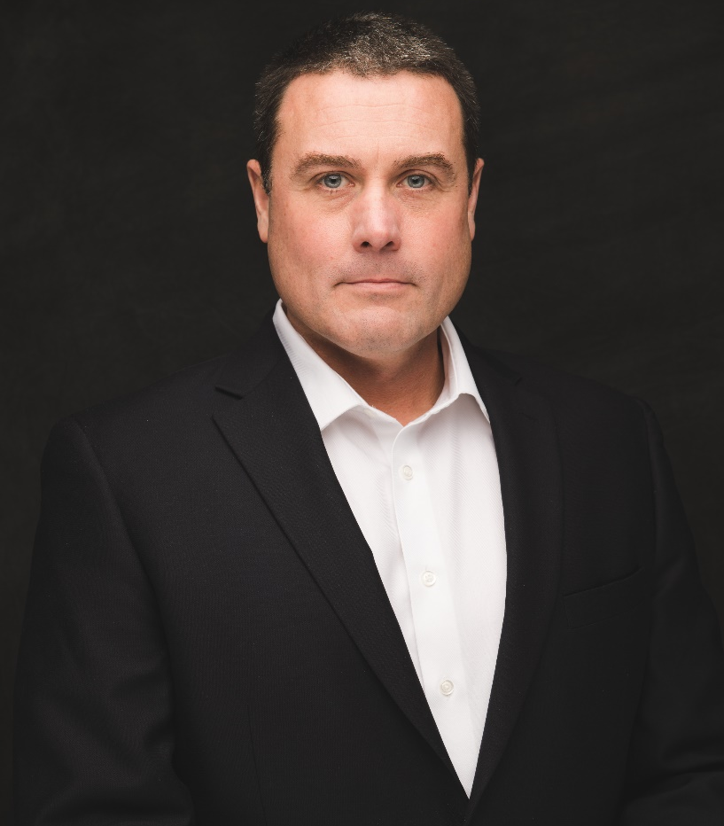

Adam S. Hardage
Chief Executive Officer

Adam Hardage is the CEO and Co-Founder of Remote Health Solutions (RHS), a telemedicine services company based in Midlothian, VA. RHS is building the largest clinically integrated network of independent medical Providers in the nation with the mission to defend medical freedom and provide healthcare with integrity. Previously, Mr. Hardage served for 20 years as a military and intelligence operations officer. His wartime service includes tours in Iraq, Afghanistan, and West Africa; as well as other operational service around the world. Mr. Hardage earned his Masters in Business Administration (MBA) from Virginia Commonwealth University School of Business and is a graduate of the US Air Force Academy’s Class of 1997. He is married with two children.

